Setting a Goal in Renaissance Math

  - Step 1-
- Log onto Renaissance
  - https://hosted165.renlearn.com/13656/Public/RPM/Login/Login.aspx?srcID=t
    - You can get to it from http://fairchildwheeler.org/
  - Click on STAR math

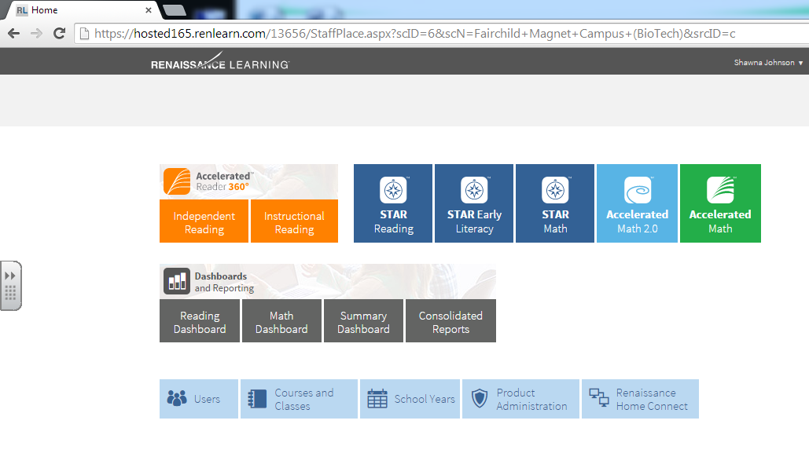
  - Step 2-
- Click on:
  - Screening, Progress Monitoring & Intervention
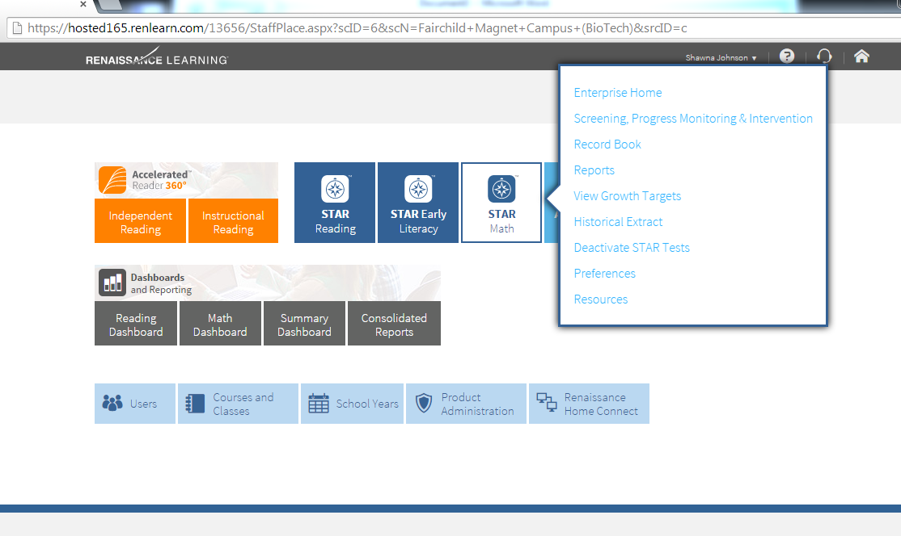

  - Step 3-
- Click on the drop-down arrow under “class”

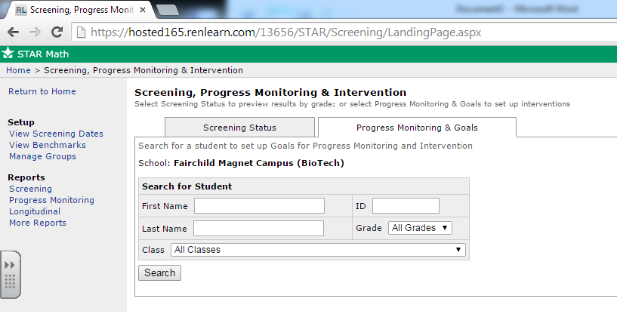

  - Step 4-
- Find you class and CLICK on it

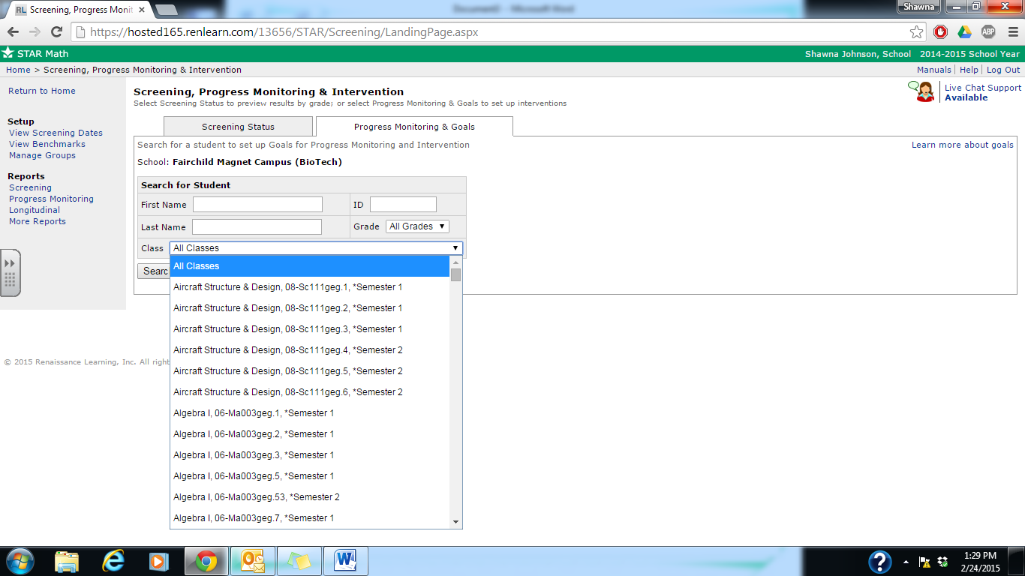

  - Step 5-
- Click on the students name
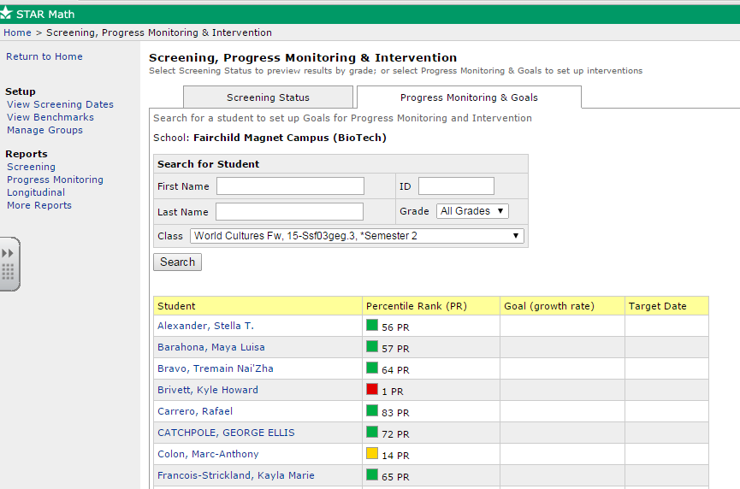

  - Step 6-
- Click on “Add Goal”

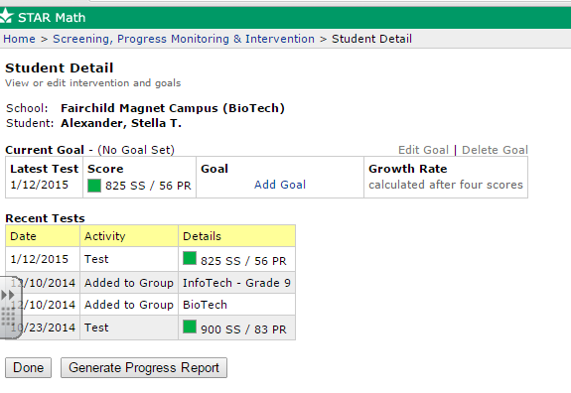

  - Step 7-
- Under “intervention Name”
  - Write in SRBI
- Under “Goal End Date”
  - Choose June 5, 2015
- Click
  - Calculate Goal

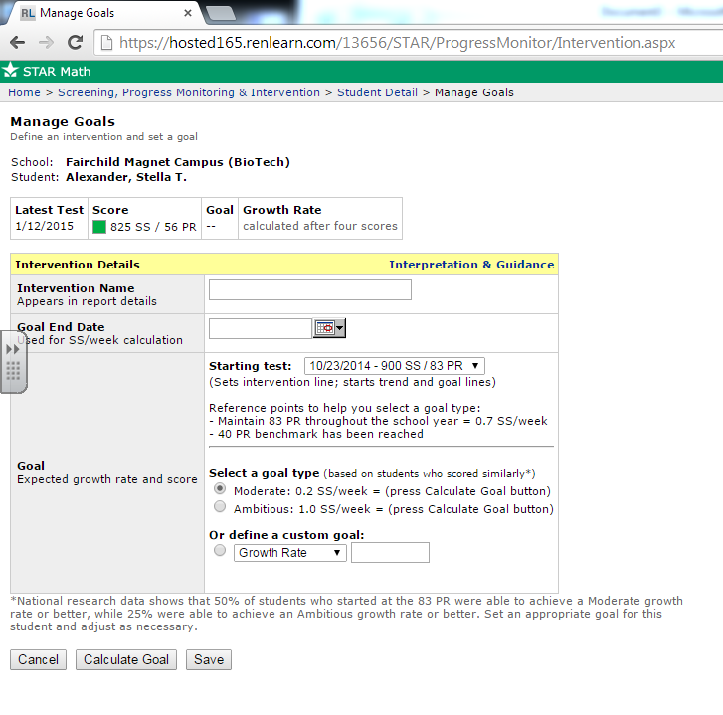
Starting test:
- Should be automatically set on the 10/23/2014 date
Select a goal type:
- Should be automatically set to moderate
June 5, 2015
Type SRBI in here

Click on “Calculate Goal”

  - Step 8-
- Once you click “calculate Goal” you will see the screen below
- Make sure to click SAVE

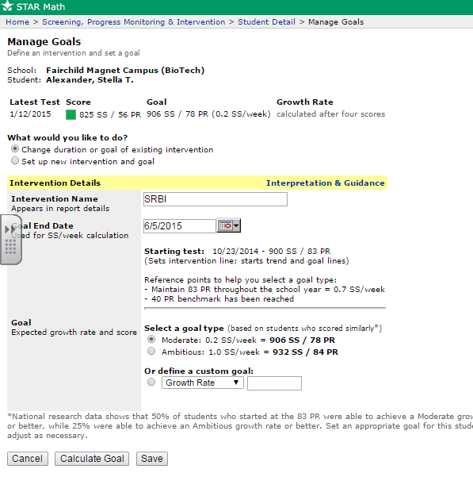
  - Step 9-
- Once you click save you will see the screen below
- Click “done”

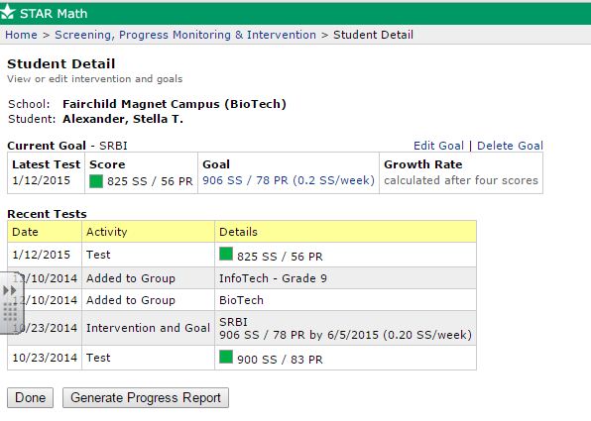

  - Step 10-
- By clicking done you are brought back to one of the first pages
- You MUST click YOUR CLASS AGAIN and do the process all over again (go back to step 4)

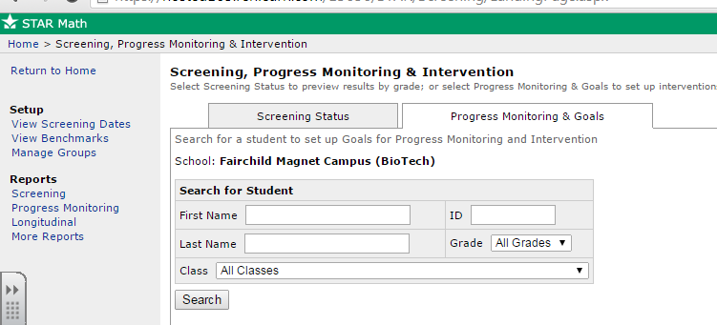

  - Once you have been successful and you go to log back in you will see the previous student- see below


